View-

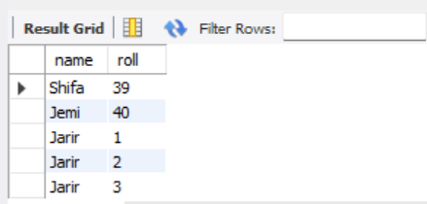

create view stu_info as select name,roll from STUDENT_DATA;

select * from stu_info;

trigger-

student data

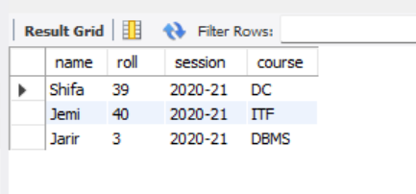

Table3-

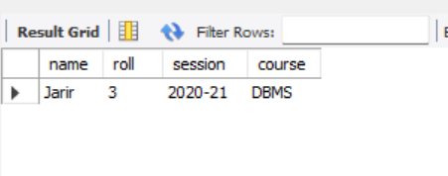

create trigger table5 after insert on STUDENT_DATA for each row insert into table3 values(new.name,new.roll,new.session,new.course);

INSERT INTO STUDENT_DATA(name,roll,session,course) VALUES('Jarir',03,'2020-21','DBMS');

select * From STUDENT_DATA;

select * from table3;

***View-***

***Main table: student_data***

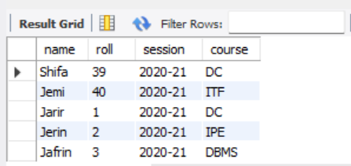

***View table:***

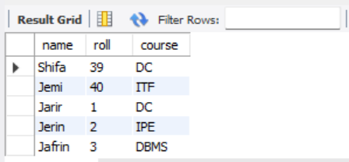

create view stu_info as select name,roll,course from STUDENT_DATA;

select * from stu_info;

***view table update operation:***

***Before:***



***update:***

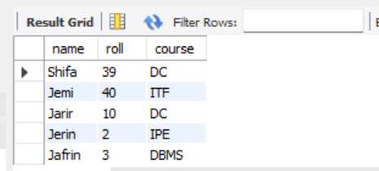UPDATE stu_info SET roll= 10 WHERE roll=01;

***view table delete operation:***

***Before:***



***Delete:***

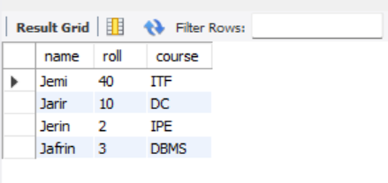

***Trigger:***

***Main table: student_data***



***After triggering insert operation main table: student_data***

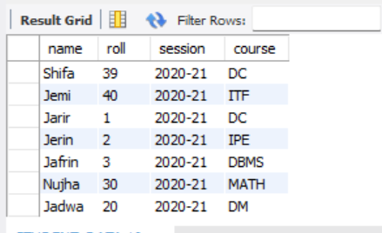

***After triggering insert operation trigger table:table3***

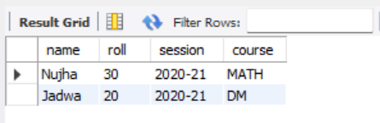

create trigger table5 before insert on STUDENT_DATA for each row insert into table3 values(new.name,new.roll,new.session,new.course);

-- insert

INSERT INTO STUDENT_DATA(name,roll,session,course) VALUES('Nujha',30,'2020-21','MATH');

INSERT INTO STUDENT_DATA(name,roll,session,course) VALUES('Jadwa',20,'2020-21','DM');

select * From STUDENT_DATA;

select * from table3;

***After triggering update operation main table: student_data***

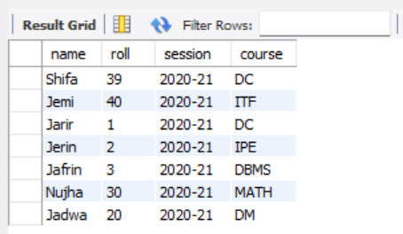

***After triggering update operation trigger table:table3***

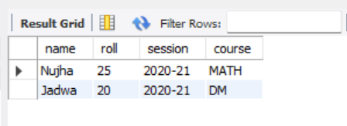

-- update

UPDATE table3 SET roll= 25 WHERE roll=30;

select * From STUDENT_DATA;

select * from table3;

***After triggering update operation main table: student_data***

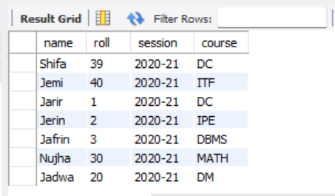

***After triggering delete operation trigger table:table3***

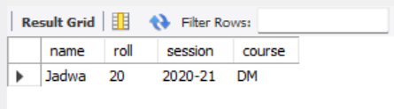

-- delete

delete from table3 where name='Nujha';

select * From STUDENT_DATA;

select * from table3;